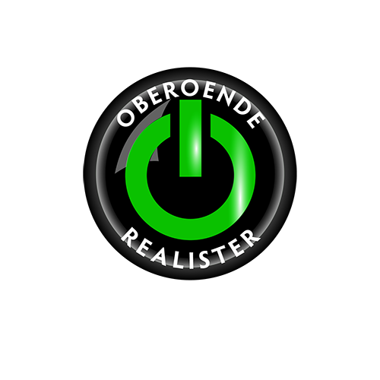
For continued development, safety and quality of life throughout Hagfors Kommun – vote for us in this autumn’s important municipal and regional elections.
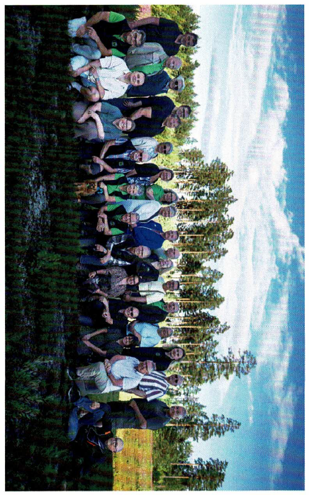
POLITICS FOR ORDINARY PEOPLE, BY ORDINARY PEOPLE!
OBEROENDE REALISTER (OR)
We are not tied down by political ideology. We listen to and talk with all parties in the municipal council. Our focus is on the issues themselves and on finding the best and most sensible solutions for the people who live here.
Under OR’s leadership, Hagfors has gone from stagnation to strong development and renewed confidence in the future across the whole municipality.
And we intend to keep that progress going for at least another four years!

This is what we want to achieve from 2026 to 2030:
- Build for the future – including a new school in Ekshärad
- Create a new care facility in the former hospital in Hagfors
- Develop a new green public square in Hagfors – an attractive place where people can meet
- Senior- and assisted-living housing in Ekshärad and Sunnemo
- Continue investing in playgrounds and public bathing areas
- Improve street and public lighting throughout the municipality
- Protect our beautiful lakes and ensure a safe Route 62
- Work to bring a new correctional facility and more government jobs to Hagfors
- Continue investing in the development of town centers across Hagfors Kommun
- Support and strengthen our local associations and clubs
- Protect the vital air connection to Arlanda
- Further develop culture and tourism throughout the whole Kommun
- Use more locally produced and environmentally responsible food in our kitchens
OR wants to make sure that Hagfors continues to have a real say in important decisions that affect our municipality – for example when it comes to dams, air connections and the location of government services.
POLITICS FOR ORDINARY PEOPLE, BY ORDINARY PEOPLE!

OBEROENDE REALISTER (OR)
We are proud of how we have developed our municipality over the past eight years – but there is still plenty left to do.
OR wants to ensure high quality in schools, healthcare and social care.
We want Hagfors to have a stable economy, without cutting back on quality or sacrificing future ambitions.
OR’s candidates are ordinary people with strong roots in the local community – people who want to help build a good future for the whole municipality.
We dare to act, and we want to move forward. Hagfors should be one of the best and safest places to live, work and build a future.
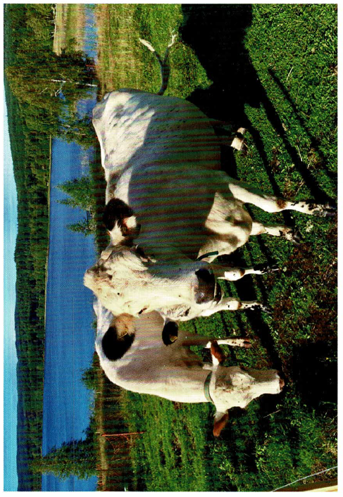

OBEROENDE REALISTER (OR)
All of Värmland needs us!
This autumn, you can also vote for Oberoende Realister in the Regional election.
We are working together with local parties from different parts of Värmland. Candidates from OR and from the other local parties will stand together on OR’s regional election list.
Over the past eight years, we have helped renew Hagfors and shown that real change and development are possible. With Oberoende Realister, you vote for progress and new ideas.
These are some of the issues that matter most to us:
- Healthcare where it is needed – close to home
- Primary care centres that truly provide good care
- Mental healthcare that actually works
- Shorter waiting times throughout the healthcare system
- Regional development and good conditions for strong local businesses
- A stable energy supply, while keeping control over our own natural resources
- Protecting the folk high schools (folkhögskolor) – an important alternative for many people
- Better public transport throughout Värmland
- More support for arts and culture across the whole region
OR focuses on the issues that really matter to the people of Värmland – without being tied down by political or ideological labels.
For stable and accessible healthcare – give OR your vote!

